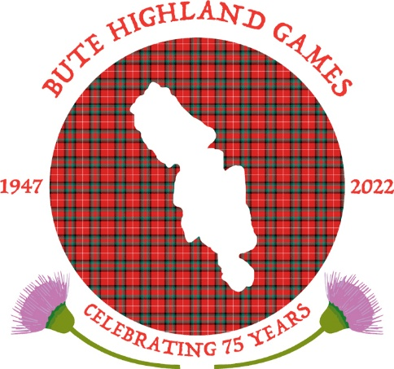
BUTE HIGHLAND GAMES

PRESENTS
(Under Scottish Athletics Laws & Rules)
THE HEAVY EVENTS CHAMPIONSHIPS
----------------------------------
The Duke of Rothesay Trophy
At the Public Stadium, Rothesay on Saturday 20th August 2022

Events Commence 1.00pm Approx.

All athletes must wear kilt & hose

EVENTS
Putting the 16lb Shot
Throwing the 28lb Weight for Distance
Throwing the 16lb Scots Hammer
Throwing the 56lb Weight for Height
Tossing the Caber

MENS EVENT PRIZES
1st £340 2nd £280 3rd £200 4th £150 5th £100 6th £70 7th £60 8th £50

LADIES EVENT PRIZES
1ST £180 2ND £150 3RD £100 4TH £80 5TH £60

ENTRY FEE £5
NO ENTRY ACCEPTED UNLESS ACCOMPANIED BY FEE
-----------------------------------------------------------------------------------------
ENTRIES CLOSE FRIDAY 27th July 2022 To ALAN PETTIGREW
21 Montfode drive Ardrossan, AYRSHIRE. KA227ls
Telephone 01294 538179 Bute Games
NAME________________________________________________
ADDRESS_____________________________________________
______________________________________________________
CLUB_________________________________________________
DATE OF BIRTH_______________________________________
SAF NO;__________________SGA NO: ___________________

Bute Highland Games will contribute towards travel expenses

THE COMMITTEE RESERVE THE RIGHT TO WITHHOLD ANY PRIZES IF INSUFFICIENT ENTRIES

