Competitor’s Number
(Official Use Only)
BUTE HIGHLAND GAMES
Saturday 20th August 2022

JUNIOR ATHLETIC EVENTS - ENTRY FORM
Primary School Level
Please submit entries by Saturday 13th August 2022. Late entries may be accepted at the Committee’s discretion
Please complete in BLOCK CAPITALS.

Surname: |  | First name:
Address:  (This will be the address we will post correspondence to) |  | Date of birth:
Age:
(On Games’ Day)
Town: |  | Tel.No.:  (Include area code)
County: |  | Parent/Carer’s  Email address:
Postcode:
Competitor’s additional details as applicable
School name:
Club name:
Tick boxes as applicable
Male: | Female: | Local competitor:
Events entered (tick boxes as applicable)
1. Under 9 - Boys’ 100 metres ☐  3. Under 9 - Boys’ 200 metres ☐  5. Under 10 - Boys’ 100 metres ☐  7. Under 10 - Boys’ 200 metres ☐  9. Under 11 - Boys’ 100 metres ☐  11. Under 11 - Boys’ 200 metres ☐ |  | 2. Under 9 - Girls’ 100 metres ☐  4. Under 9 - Girls’ 200 metres ☐  6. Under 10 - Girls’ 100 metres ☐  8. Under 10 - Girls’ 200 metres ☐  10. Under 11 - Girls’ 100 metres ☐  12. Under 11 - Girls’ 200 metres ☐
Total fee enclosed (£1 per event):
Emergency contact details
Surname: |  | First name:
Emergency Tel.No.: |  | Relationship to you:
Parent/Carer’s Signature: |  | Date:

Please complete and return form together with a stamped self-addressed envelope and payment of
fees (cheques payable to Bute Highland Games) to:-
Shaun Lyon , 61 Marine Rd, Port Bannatyne , Isle of Bute PA20 0LS
Only competitors who have submitted a stamped self-addressed envelope with their entry fees
will receive an admission ticket to the Games.
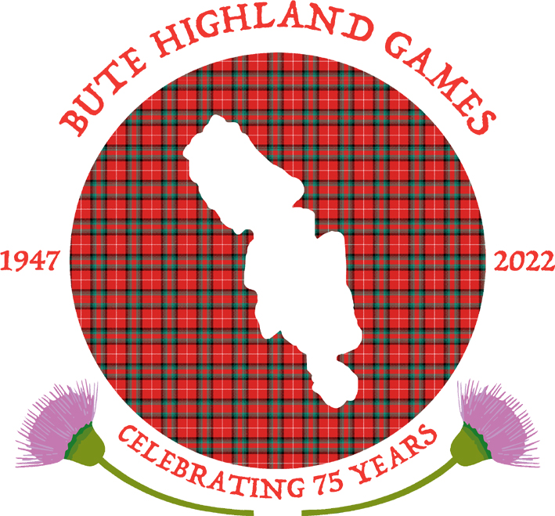
Tickets will be distributed from the 14th July onwards.

